New Member Welcome Wizard

UX Midpoint Submission

April 25th, 2018

# Idea

The idea is to create an onboarding tool for members of a network marketing company. The type of products sold here could be anything, but for the purposes of this project, the company will be selling coffee. The new members will be guided through the various features of the site, shown informational videos and instructed on how to complete their profiles. Gamification will also be incorporated in the form of badges and possibly points.

At the moment, there will be four steps in the wizard. The user will be asked to take a tour of the site, upload a photo to their profile, browse the videos, and then finally explore the question and answer section.

Points will be awarded after completing each of these steps, and when all of the steps are completed, a badge will be awarded. The wizard should be easily accessible to the user if they close it before completing all of the tasks

With this project, I hope to create a process and design that encourages users to complete the whole process and stay engaged in the site. Future plans include more tasks and badges that the user can continue to earn, which will hopefully allow them to sell more product.

# Research

An online survey was created and sent out to about 20 people. Eight responses were received.

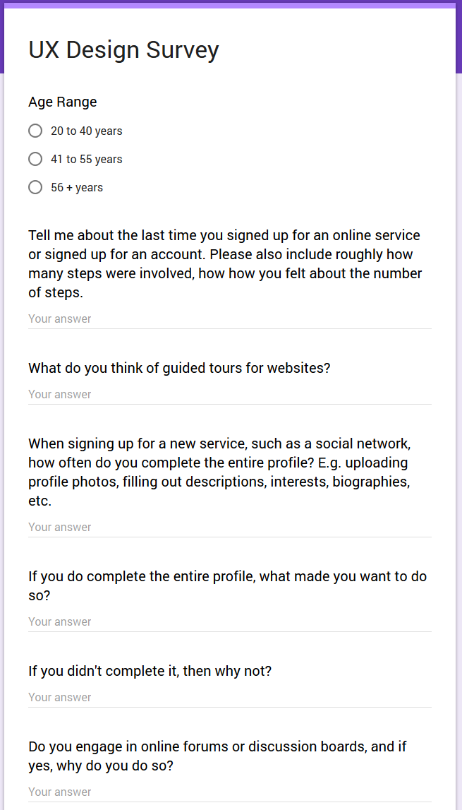

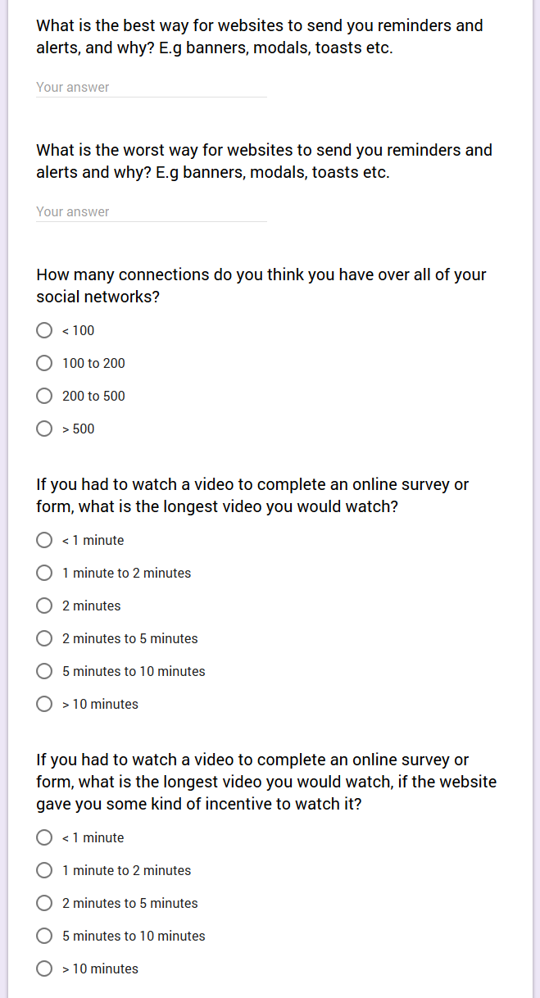

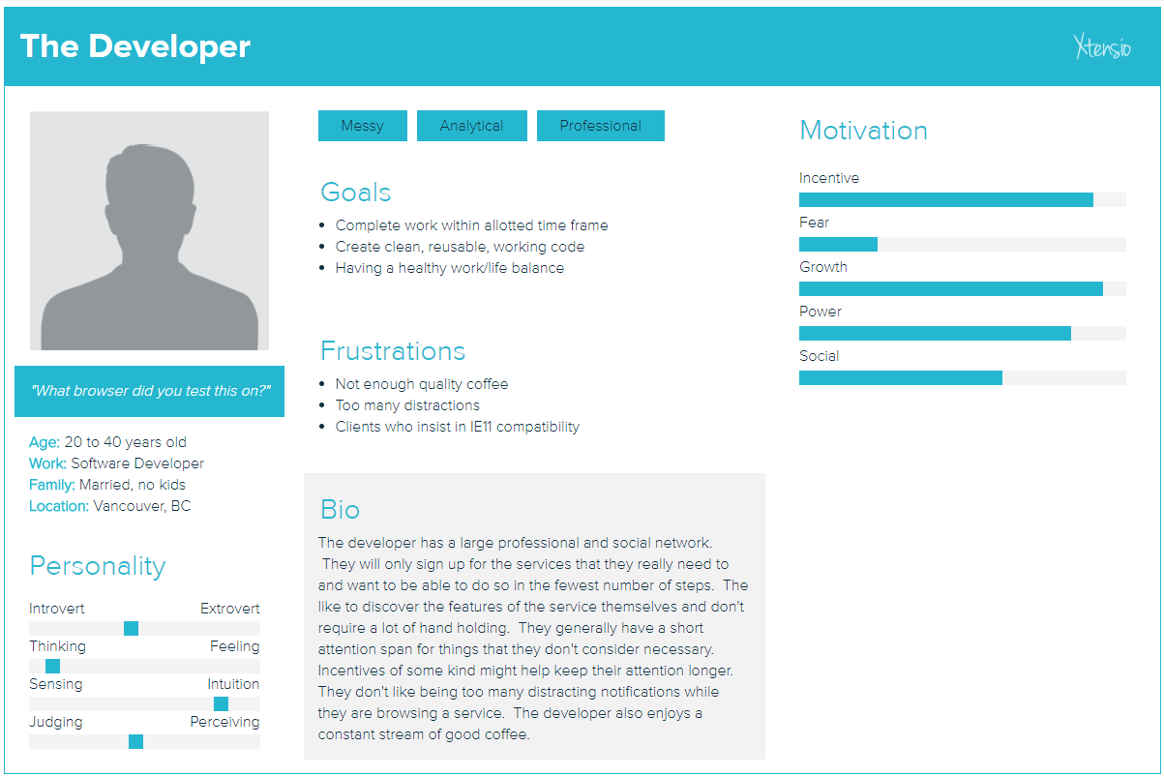

# Information Architecture

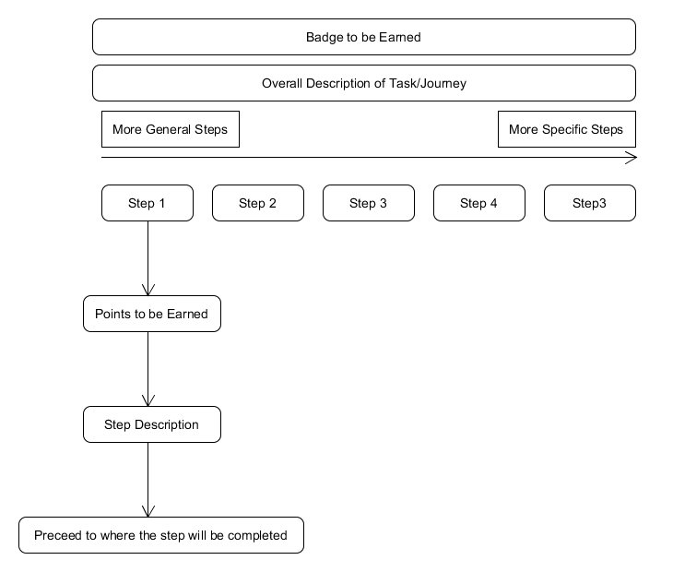

# User Flow

